Project Report:

Course:
DIGITAL LITERACY
(Course Code – CSE1001)

MADE BY :-
AKANKSHA CHANDA
Reg No.: 25BOE10050
Branch: BIOENGINEERING
School – SBET

Introduction

As a Student Digital Ambassador at VIT Bhopal University, my role is to help peers navigate the digital world responsibly. This project, part of the CSE0001 Digital Literacy course, involves building a comprehensive Digital Literacy Portfolio. The portfolio demonstrates practical skills across five modules: creating an awareness infographic, establishing a professional digital presence, exploring coding and collaboration tools, applying email etiquette, and developing a cybercrime awareness resource.

All work is organized in a public GitHub repository, which itself reflects the digital competencies gained. Through this project, I have engaged with tools such as Canva, GitHub, LinkedIn, HackerRank, Google Forms, and the National Cyber Crime Portal. This report documents each task, the deliverables created, and my reflections on the process, showcasing how digital literacy can be applied both personally and in the role of a Student Digital Ambassador.

- Task-1: Infographic Presentation
- Tool used: Canva (online design tool)
- Description:
I created a one-page infographic page titled “Digital Literacy for Students” using Canva. Some important queries regarding this:
- What is digital literacy ? – the ability to find, analyse and cultivate information online.
- What it shows ? – It shows a pictorial representation for the fundamentals used in digital literacy by checking the data and safe internet practices along with its workshops.
The infographic uses clear, short bullet points, and a colour palette that is eye catching.
Reflection:
During the process of making of this informatic, I found Canva’s template and presentation library collection very helpful. The interesting and engaging part was the usage of different colour background, text which made it more eye catching as well as informative. The only difficulty was ensuring the final export remained high resolution for clear viewing.

- Task-2: Portfolio
- Platforms chosen: GitHub, LinkedIn, Kaggle
- Purpose of each platform:
  - GitHub: A public platform for sharing code and version control. I created many repositories where my workings have been reflected in the fields of coding, digital literacy and python programming
  - LinkedIn: A professional networking application often used as an social media website for professionals. I filled my educational details and also added my professional workings, interests and future goals.
  - Kaggle: A online community for data science and machine learning. I plan to use it for data analysis and to compete in various competitions.
- Screenshots:
GitHub profile: 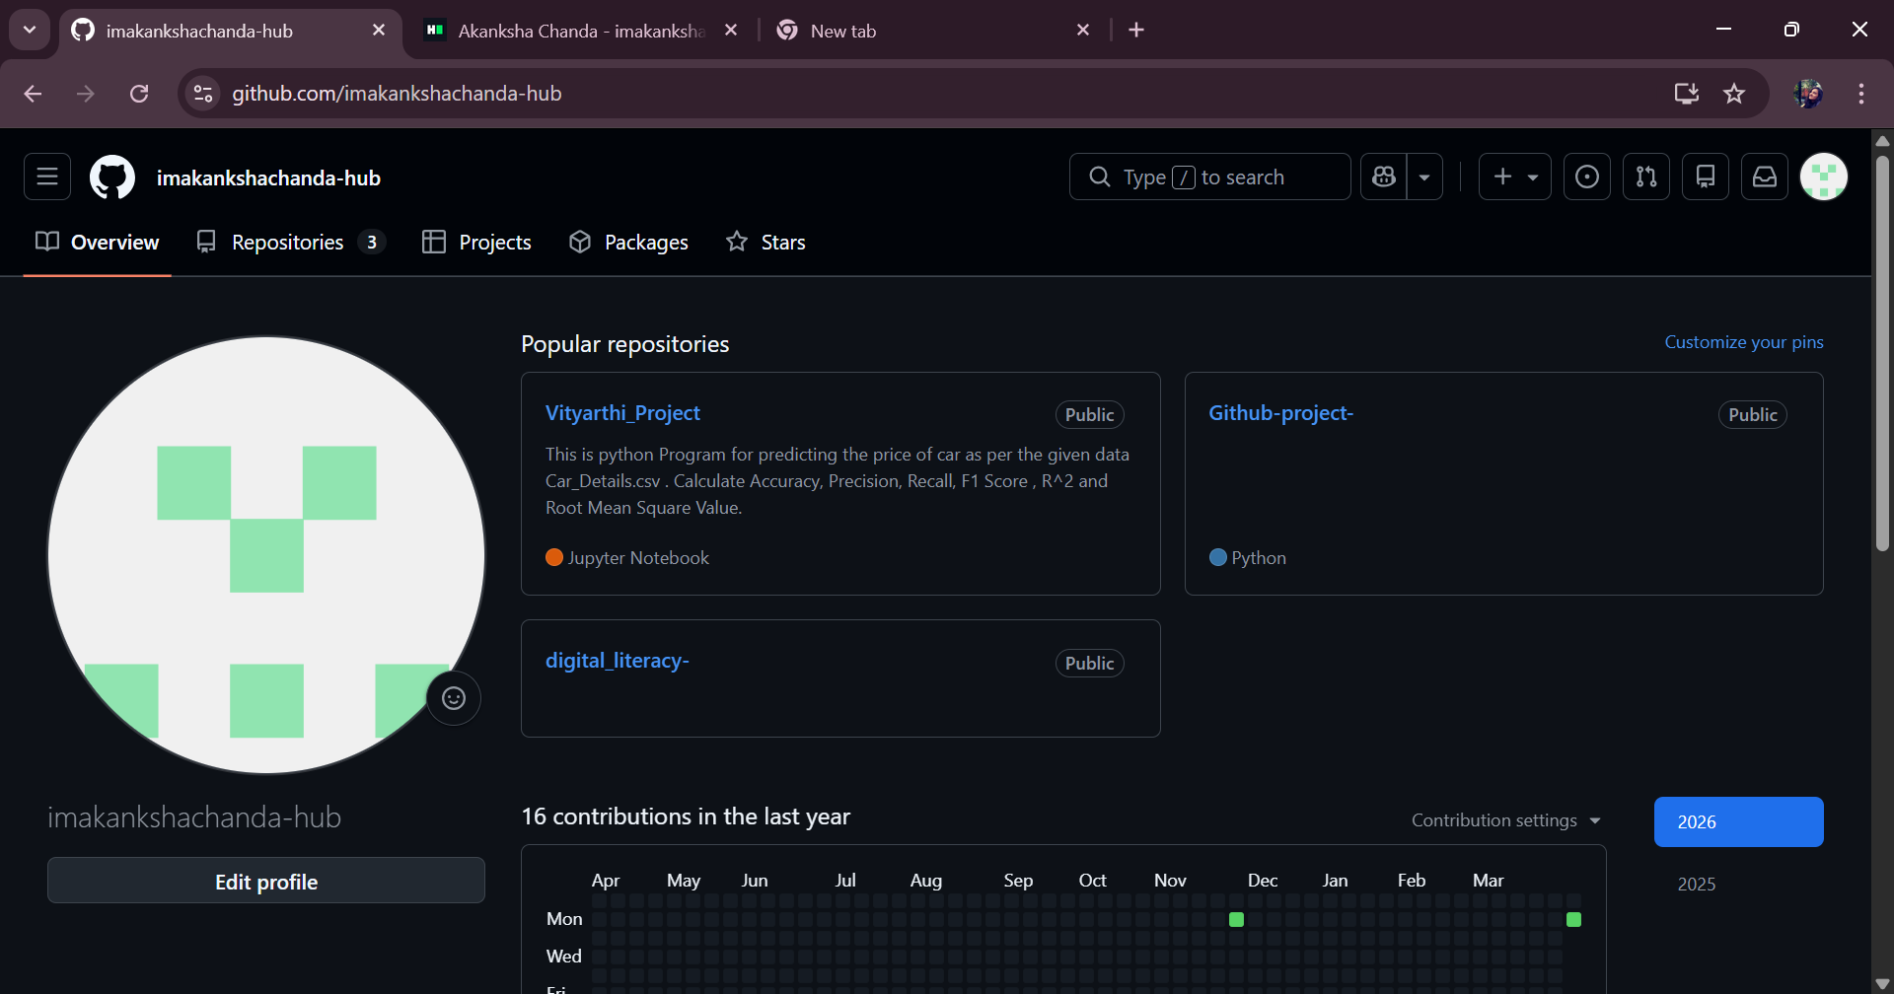

LinkedIn profile:
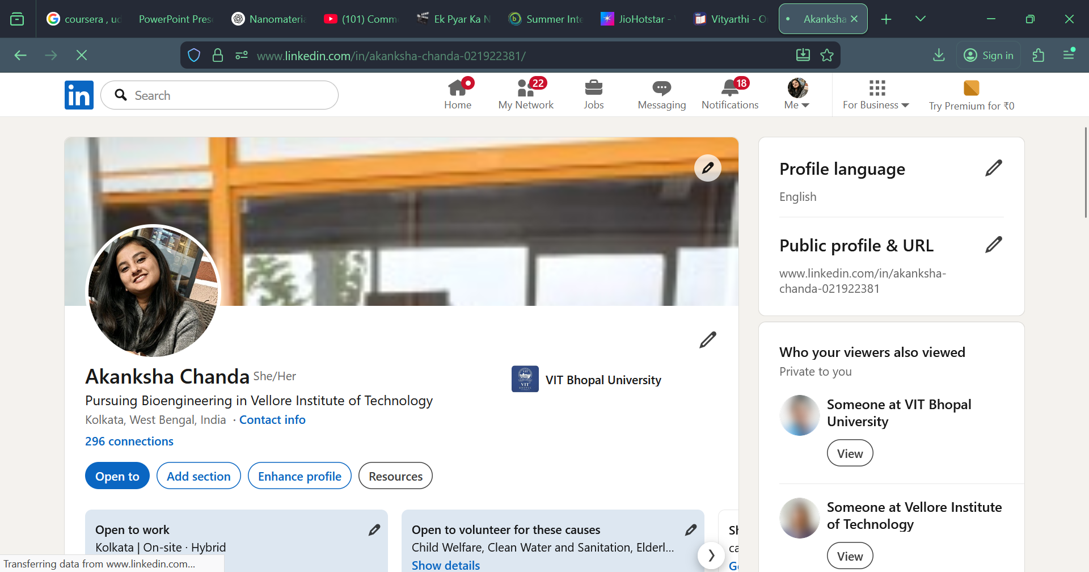

Kaggle:
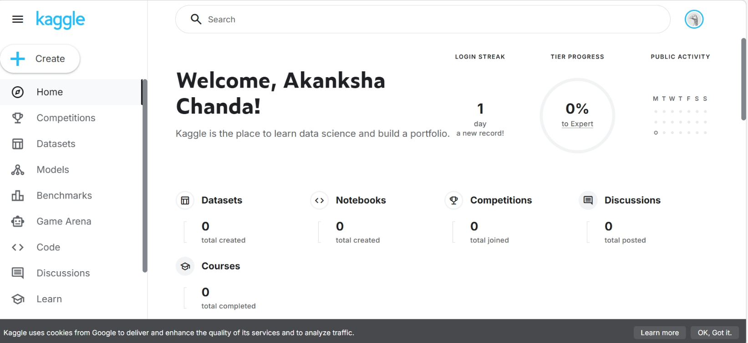

- Reflection and future plans:
Over the next four years I will use these as follows:
- GitHub to preserve my academic projects and contribute to open-source to build a strong portfolio.
- LinkedIn will help me to build connections with alumni, business professionals, recruiters and industrialists – I plan to regularly update it with my achievements and internship workings.
- Kaggle will be my learning hub allowing me to form a comprehensive digital identity.
Together, these platforms will form a comprehensive digital identity that reflects both my technical and professional growth.

- Task-3: Platforms
Platform used:
I created an account on HackerRank and completed the Python Basics and intermediate challenge in the Python domain and Problem Solving. The platform provided instant feedback and awarded a badge upon completion of these challenges and gave me a 3 star badge.
Screenshot:
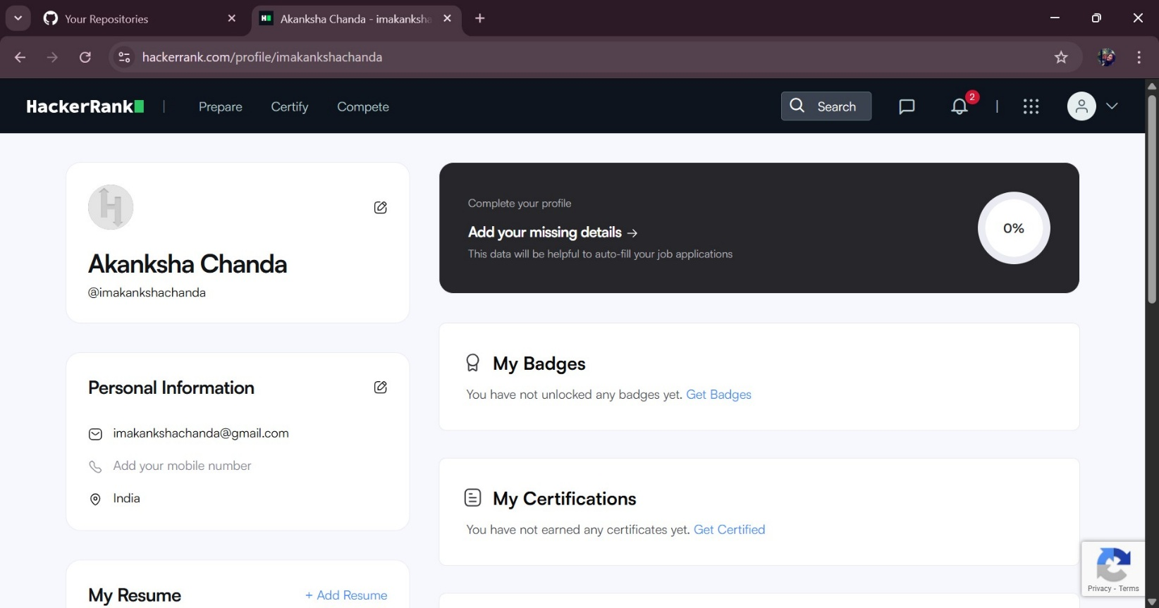

Reflection:
HackerRank helped me refresh basic coding syntax in a competitive and engaging way, which will be useful for technical interviews and competitive programming. Google Forms is an excellent tool for gathering feedback or conducting quizzes – I can see myself using it for class surveys, event registrations. Both tools are simple to use also highly effective for academic and collaborative purposes.

- Task-4: Email etiquette
Fictional Scenario:
A case of a student who posted a (rant) about a professor on a public social media account. The post went viral within the university students and community leading to disciplinary action, damaged reputation and worsened relationships.
Alternative:
If the student had used a private channel or simply hold back from posting; the outcome could have been avoided. He could have resolved the problem by complaining the thing to the university heads and board members rather than spreading mis-information and rant also by personal meetings with the professor would have avoided many circumstances and would also have better relations between the student and the professor. This shows how a misunderstanding and mis-information have not only made the reputation of the targeted professor bad but also worsened the situation of the student as well as the institution.

- Task-5: Case Study
What surprised me most while researching phishing was how well organised fake websites can be – they often copy logos, designs and even security badges to look like a professional website and gain authority. I used to think I could easily spot a phishing attempt, but now I realise that even tech-people can be fooled easily.
Change:
- One habit I will change is to never click links in uninvited emails; instead, I will manually type the official URL into my browser to look for tat actual website for which the email was shared to me.
- Another habit would be using two step verification for any personal or professional public profiles and accounts so that any other fishy scammers could not hack me.

7. Conclusion
Completing this Digital Literacy Portfolio has given me hands-on experience with a wide range of digital tools and concepts. From designing an infographic to setting up professional profiles, solving a coding challenge, crafting professional emails, and researching cybercrime, I have built a solid foundation for navigating the digital world responsibly. As a Student Digital Ambassador, I now feel confident in guiding my peers toward similar practices. This repository and report will serve as a reference for my future endeavours and a testament to my commitment to digital literacy.

8. References
- Canva: Create stunning visual content. https://www.canva.com
- GitHub: Build and ship software. https://github.com
- HackerRank: Practice coding, prepare for interviews. https://www.hackerrank.com
- National Cyber Crime Reporting Portal: Report cybercrime. https://cybercrime.gov.in
- VIT Bhopal University. (2025). CSE0001 Digital Literacy Project Brief.

